Noise Management Plan
  - Micro Surfacing
  - Contract No: 0040/23-0018 2024/2025
SHIRE OF NANNUP

EMERGENCY CONTACT NUMBERS
Description |  | Telephone
Ambulance |  | 000
Fire |  | 000
Police |  | 000
SES Assistance in Floods and Storms |  | 132 500
NON EMERGENCY CONTACT NUMBERS
Employee Assistance Program |  | 1800 808 364 or SMS 0439 449 846
Poisons Information Centre |  | 13 11 26
National Non-Emergency Police Assistance line |  | 131 444
National Non-Emergency Health Advice |  | 1800 022 222
MICRO-SURFACING CONTACT NUMBERS
Name/Email | Position |  | Mobile
Mark Parsons  Mark.Parsons@fultonhogan.com.au | National Operations Manager / First Aider (24Hr) |  | 0447 474 194
Fernando Marinelli  Fernando.Marinelli@fultonhogan.com.au | Fulton Hogan Representative / Project Manager / First Aider / Mental First Aider (24Hr) |  | 0499 501 563
Serdar Topal  Serdar.Topal@fultonhogan.com.au | Supervisor / First Aid / Mental First Aider (24Hr) |  | 0499 700 763
Nicki Kuppers  nicki.kuppers@fultonhogan.com.au | National People Coordinator |  | +61400149525
Simon Mcleish  SimonMcleish@fultonhogan.com.au | Regional Safety Advisor |  | 0407 681 750
BUSINESS UNIT DEPOT
Company Address: 124 Doherty’s Road, Laverton North, VIC, 3026
Phone | 03 8360 4900
Email | Microsurfacing@fultonhogan.com.au

Noise Management Plan – Micro Surfacing- Au
Contents
1. Introduction 3
1.1. Purpose/Legislation 3
1.2. Scope 3
1.3. Work locations 3
Location 3
2. Resources, roles and responsibilities 6
2.1. Management team and responsibilities 6
2.2. Out of hours work 7
2.3. Mobile plant to be engaged 7
2.4. Operational noise levels 8
2.4.1. Worst case scenario 9
Operating paver (full revs) with a live bottom truck reversed up with reverse alarm still operational (truck not in neutral). 9
Predicated noise levels in dBA = 9
Clear work area with no structures adjoining the work area. 9
Still day and no passing traffic. 9
Plant operating to manufactures specifications. 9
No sound barries installed 9
2.4.2. Where noise will be generated 9
Areas where the noise will be generated from and how. 9
Site noise - 9
• Live bottom trucks delivering the product to the paver – truck noise and the reverse alarm when reversing to the paver 9
• Operation of the Bergkamp paver - engine noise during operation 9
• Sweeper – engine noise and broom noise during operation 9
• Sthil blower – during high revs blowing loose aggregate 9
Stack site noise - 9
• Wheel loader – engine noise when loading product onto the live bottom trucks and reverse alarm 9
• Petrol pump – engine noise when transferring product from the bulk tanker to the live bottom trucks 9
2.4.3. Noise controls 9
2.5. Noise monitoring 10
2.6. Method of providing public notification 10
2.7. Compliant management and response 10
2.8. Stakeholders and other interested parties 11
2.9. Letter drop sample 11
3. Revision History 11

- Introduction
  - Purpose/Legislation
This Noise Management Plan provides the workplaces with the guidelines to perform their work activities in full compliance with the Environmental Protection (Noise) Regulations 1997 (reg 13) for construction work outside the hours of 7am to 7pm Monday to Friday to Saturday and public holidays and AS 2436 Guide to noise and vibration control on construction, demolition and maintenance sites.
A noise management plan is required as per Main Roads Contract No:0040/23-0018 to ensure full compliance of the night operations.
  - Scope and Dates
The location of the works is the Vasse Highway - Nannup Townsite between SLK 57.73 and 59.08. Works are scheduled to commence on the 10th of February and to be completed on 14th of February. Time frames and dates may be subject to change due to unforeseen circumstances or delays outside of Fulton Hogan controls.
Working hours are from 19:00 to 5:00
An approved Traffic Management Plan (TMP) will be prepared and implemented for all projects involving after-hour road works.

  - Work locations

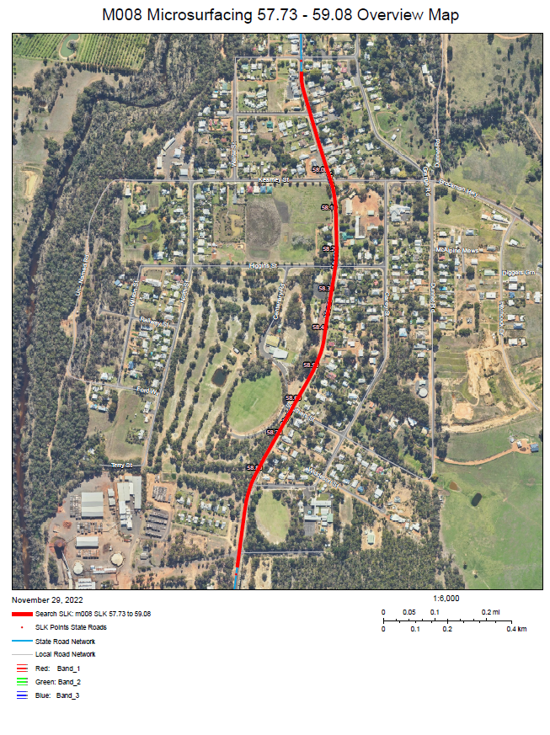
- Map 1: Work Location Map
- Resources, roles and responsibilities
  - Management team and responsibilities
Micro Surfacing management has the overall responsibility for the implementation of this Noise Management Plan and ensuring the team understand the requirements.
- Act on any excessive site noise emissions
- Revise works/activities where required to minimise impacts on the neighbouring properties
- Monitor and reporting noise issues
- Communicate with the client as required
- Fulton Hogan team is responsible for implementing noise reduction as required

  - Out of hours work
Need for the work to be done out of hours
The aim would be to complete the works during day light hours but due to a variety of factors this may not be possible due to:
- The volume of traffic that will be impacted causing consistent delays and congestion
- Over runs due to restricted access from traffic volume/movements
- Risk to the Fulton Hogan team, general public or client staff
- Adjacent properties or businesses restricting deliveries or general access
- Access or responding to emergency services from traffic delays/congestion
- Safe access for people and plant

  - Mobile plant to be engaged
The effort shall be made to select plant and equipment that minimises the generation of noise and that is in good repair, it is acknowledged that the equipment and plant to be used will generate noise.
The following list of mobile plant will be engaged for the night works onsite:
- Bergkamp paver – paving machine
- Truck mounted live bottom tandems and semi – delivery of product to the paver
- Tractor mounted sweeper – sweeping areas to be paved
- Lighting towers - providing adequate light for night works
- Light vehicles – access across the project during works

The following list of mobile plant will be engaged for the night works at the stack site:
- Rubber tyred loader – load the live bottom trucks with product
- Truck mounted live bottom tandems and semi – delivery of product to the paver
- Bulk tanker – storage of product
- Lighting towers – providing light for night works

To ensure the equipment used is the quietest reasonably available in accordance with the requirements of AS 2436 all equipment is serviced and maintained to manufacturers recommendations.
This ensures equipment operates as intended by the manufacturer.

  - Operational noise levels
During the works the level of noise generated and received will vary due to many factors.
- Existing barriers to the work area
- environmental conditions at the time
- the specific activity
This will make it difficult to list a noise level without taking noise readings for each activity and location. A predicated level as per the general activity on the worst case to be listed and this may be above the projects actual noise levels.
Predicted noise levels from operating plant
 |  | 10 m | 20 m | 50 m | 100 m | 400 m
Paving plant | dB(A) reading at source | Predicted noise level (dB) | Predicted noise level (dB) | Predicted noise level (dB) | Predicted noise level (dB) | Predicted noise level (dB)
Bergkamp | 110 dB | 85 | 79 | 71 | 67 | 53
Truck mounted live bottom | 87 | 67 | 61 | 53 | 47 | 35
Semi live bottom | 87 | 67 | 61 | 53 | 47 | 35
Tractor mounted sweeper | 55 | 35 | 29 | 21 | 15 | 3
Lighting tower | 87 (if not solar) | 59 | 53 | 45 | 39 | 27
Sthil blower | 96 dB | 75 | 68 | 60 | 54 | 42
Light Vehicles(reversing) | 85 | 64 | 60 | 51 | 46 | 32
Stack site plant | dB(A) reading at source
Rubber tyred loader | 76.5 dB | 55 | 47 | 41 | 39 | 33
Truck mounted live bottom | 87 | 67 | 61 | 53 | 47 | 35
Semi live bottom | 87 | 67 | 61 | 53 | 47 | 35
Lighting tower | 87 (if not solar) | 59 | 53 | 45 | 39 | 27

    - Worst case scenario

Operating paver (full revs) with a live bottom truck reversed up with reverse alarm still operational (truck not in neutral).

Clear work area with no structures adjoining the work area.

Still day and no passing traffic.

Plant operating to manufactures specifications.

No sound barries installed

    - Where noise will be generated

Areas where the noise will be generated from and how.

Site noise -
- Live bottom trucks delivering the product to the paver – truck noise and the reverse alarm when reversing to the paver
- Operation of the Bergkamp paver - engine noise during operation
- Sweeper – engine noise and broom noise during operation
- Sthil blower – during high revs blowing loose aggregate

Stack site noise -
- Wheel loader – engine noise when loading product onto the live bottom trucks and reverse alarm
- Petrol pump – engine noise when transferring product from the bulk tanker to the live bottom trucks

    - Noise controls
To ensure the impact of the noise and the disturbance to the adjoining residents is minimised the proposed actions are:
- Serviced and maintained plant to prevent excessive noise and break downs
- Inducted component operators will be informed at the commencement of each shift the proposed works for the shift, start and finish chainage, any noise sensitive areas and the standard noise practices, e.g.: use of small voice and not yelling, cabins closed and use of UHF radios.
- Considerable planning to have vehicle movements conducted during the day shift e.g.: product deliveries, transfer of products and plant repairs
- Solar lighting towers (where possible) to eliminate the noise from diesel motors
- Once work commences the aim will be to continuously progress the paving along the road which will prevent an excessive noise exposure for each resident
- Written notice (letter drop) to be provided to the affected residents and businesses 48 hours prior to commencement informing them of the proposed activity and the duration
- Variable message boards to be set up communicating to the general public of the proposed works 1 week prior to commencement
- Nominated manager appointed to address any concerns or complaints that may arise from the works
- When the plant is not operational the requirement will be to lower the power to an idle or shut down to eliminate or reduce the noise generated
- Road closures to reduce the requirement to reverse and the reverse alarms operating
- Reversing alarms will be self-adjusting
- Stack sites will be designated and as far as practicable from the residential area
- Emergency services communicated of the proposed works to prevent the likelihood of interaction during a shift (lane/road closure)
- Crew to conduct themselves in appropriate manner with no yelling or swearing
- Constant shift monitoring with the aim to adjust or improve the noise management
- The sounding of vehicle or plant horns for basic communication prohibited (unless emergency)
- Noise report required for any new plant or equipment operating on site
- Truck drivers to stay in the trucks and to limit doors slamming shut
- Vehicle noise – truck speeds to be monitored
- Hand tools to be carried and not dragged
- Traffic management to place signage and stands and not to throw into their vehicle during set up/pack up
- Residential Noise exposure will be limited as the paver travels continuously at 5km/hr during operations.
- We anticipate works on the lane closest to residential side be complete within 3-4 hours, thereby reducing the noise further.
- Whilst not in operation equipment will be idled down or turned off completely.

  - Noise monitoring
Works will be conducted as per the noise management plan.

  - Method of providing public notification
The notification of the works will be conducted via the following tools:
- Variable message boards notifying the general public of the proposed works at least 1 week prior to commencement
- Residential and businesses located within 100 meters of the proposed work will be notified via a letter drop at least 48 hours prior to commencement

  - Compliant management and response
Residents and businesses affected by the works will be provided works details via the letter drop with the project manager details.
All complaints or commendations shall be recorded in CAMs.
  - Stakeholders and other interested parties
The following table details the needs of key stakeholders and interested parties to the works.
Stakeholder/Interested Party | Needs
Main Roads | Develop noise management plan
Local Councils | Develop noise management plan
Residents | Notification of the proposed work dates and times
Local Businesses | Notification of the proposed work dates and times

  - Letter drop sample
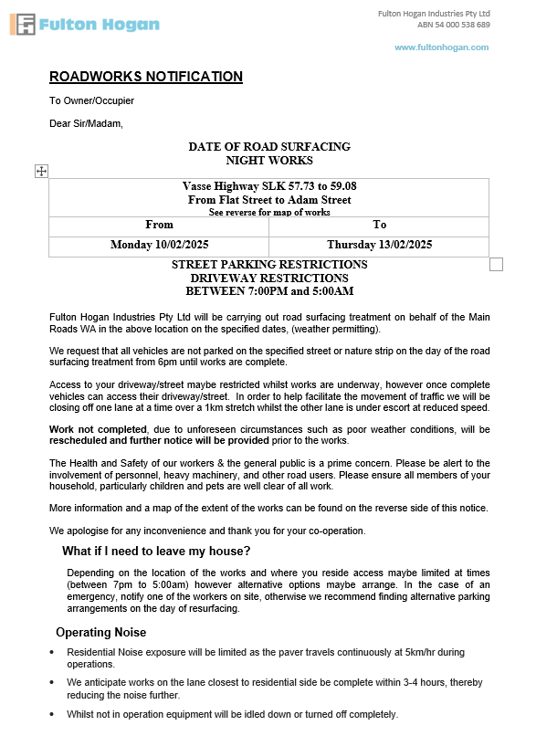

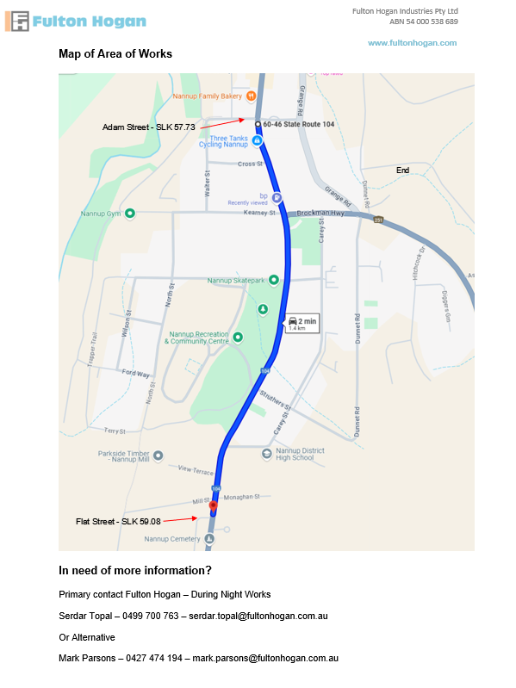
- Revision History
DATE | AUTHOR | BRIEF DESCRIPTION OF CHANGE
03/02/2025 | F.Marinelli | Noise Management Plan

